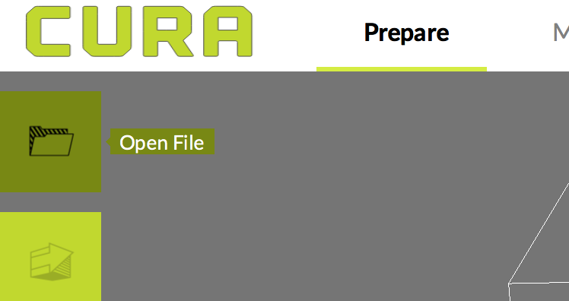
- Open Lulzbot software on computer

- Open file>locate and open your figure’s .stl file

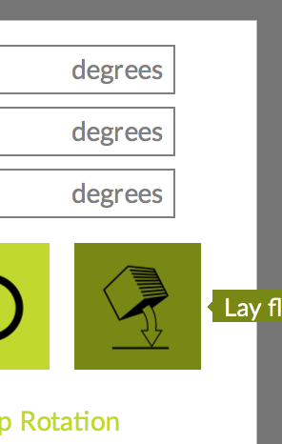
- Click on the object to select it

- Click rotate button> Lay flat (this lays the object flat on
the buildplate so it doesn’t fall over during printing)

- Click scale button> change axis with the largest value
to anywhere between 150 to 200 mm (for this project
we don’t want an object much larger than 6in in any
dimension)

- Make sure the menu on the right of the screen is on
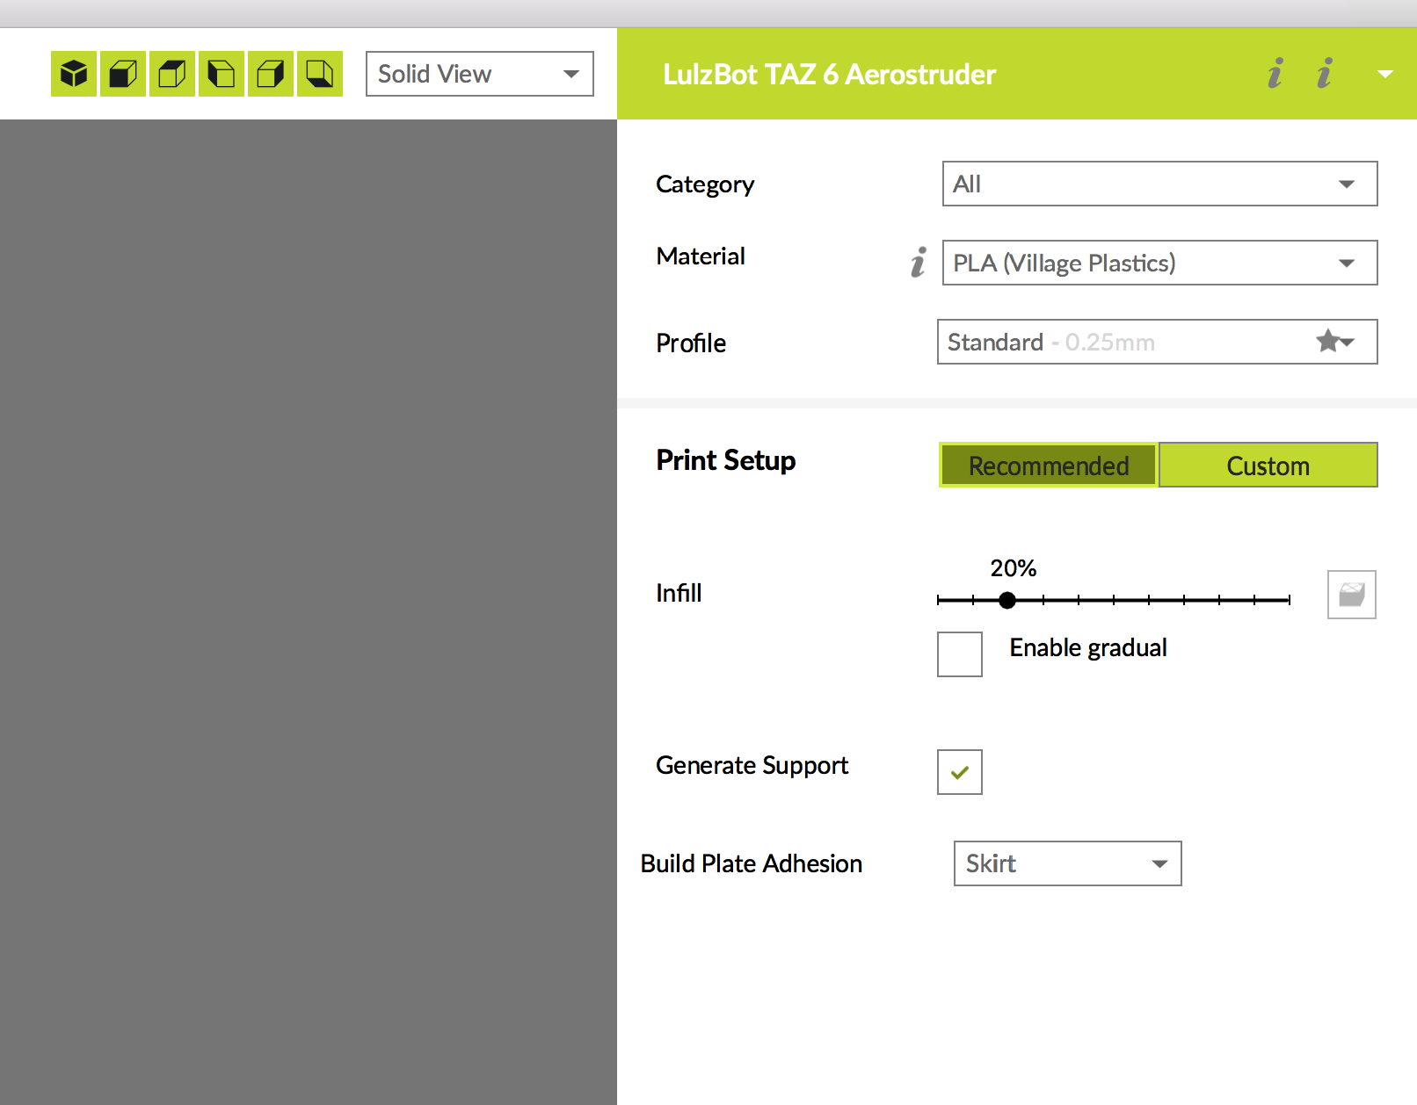
the default settings: Category- All, PLA Village
Plastic, Standard profile, 20% infill

- Click box to Generate Supports and make sure skirt support
is selected (this creates a support under the object to also
help keep it from falling over!)

- Obtain an SD card and insert it into the computer

- Click the arrow menu next to the Save to Removable
Drive button at the bottom right of the screen>
select the SD card

- Click Save to Removable Drive

11. Eject the SD card and give it to the attendant who will
insert the SD card into the 3D printer and select your file
to start printing it. The estimated print time is shown
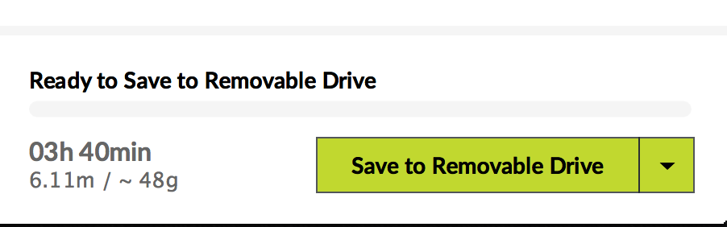
in the lower right corner of the Lulzbot software and
on the 3D printer’s screen.

