- Take a photo
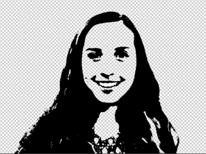
  - It does not have to be of yourself!
  - It does not have to be a smile!
  - Make sure it is clear and the background does not blend in with the subject

- Upload the photo into photoshop and follow the directions in the video to create your shadow
Outline

- Select and/or take the photos you want to include in your collage

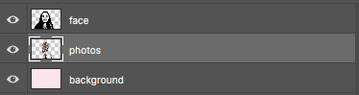
- Create a new layer and place it between your background and your shadow

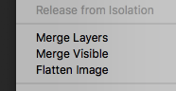
- Arrange your photos where you want them to be and then merge them into a single layer

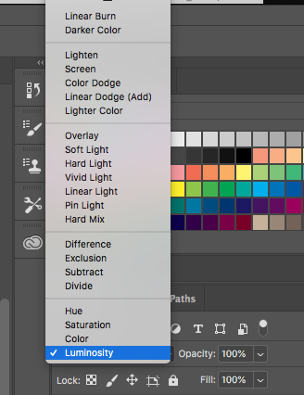
- Play around with the color settings or opacity to get a look you like

- Add a background
  - It can be a picture, color, or illustration

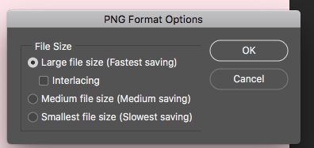
- Save as a PNG- large file

